

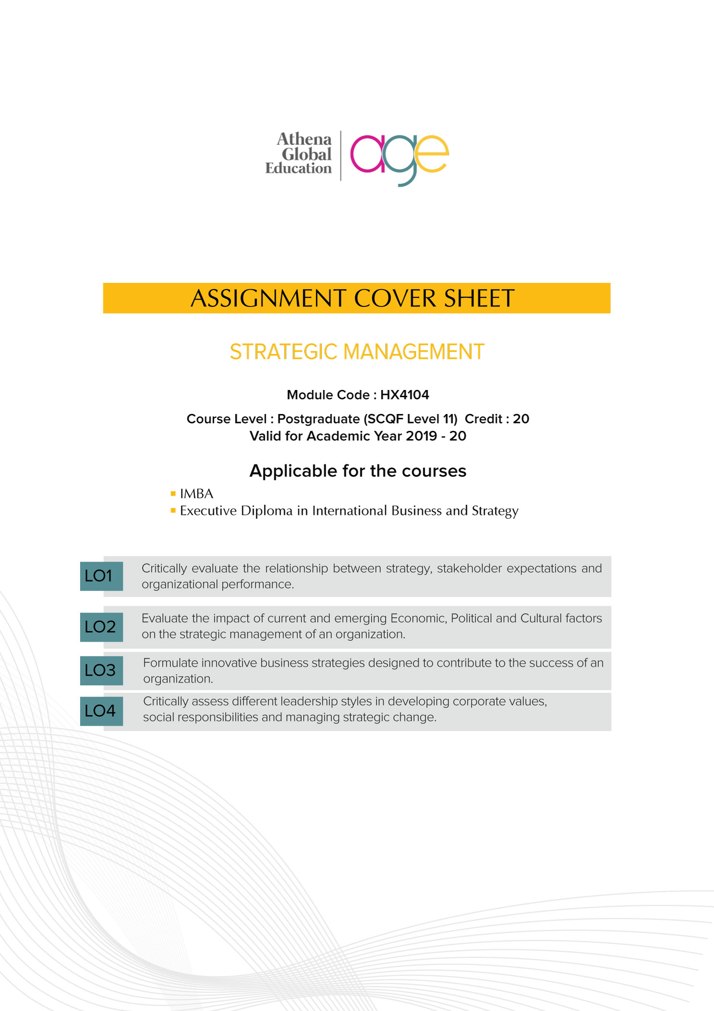

|  |  |  |
| --- | --- | --- |
| **COURSE/UNIT INFORMATION** | | |
| Course | *MBA – UCAM* | |
| Course Level | *Postgraduate* | |
| Module Name | ***Research Methods*** | |
| Awarding Body | CIQ/UCAM | |
| Module Code |  | |
| Faculty |  | |
|  |  | |
| **ASSIGNMENT INFORMATION** | | |
| Full/ Part Assignment | *Full* | |
| Assignment brief IV by | *Dr. Vivek Mohan* | |
| Assessor |  | |
| Assignment due date |  | |
|  |  | |
| **TO BE FILLED BY THE STUDENT** | | |
| Student Name | |  |
| Student ID | |  |
| Email ID | |  |
| Date Submitted | |  |

**General Guidelines**

1. Complete the 'To be filled by the student section' in the cover sheet.
2. All assignments must be submitted as an electronic document in MS word via the LMS (Use 12 Times New Roman script with 1.5 spacing between lines).
3. Student responses must be written and submitted in the assignment brief that includes the cover sheet.
4. Full Turnitin report of your responses (excluding the cover sheet) must be also submitted with the assignment brief, snapshot of the Turnitin score must be pasted before your responses in the assignment brief.
5. The results are declared only if the student has met the mandatory attendance requirement of 75% and/or minimum 50 % under extenuating circumstances approved and ratified by the academic committee and the examination board.
6. The assignment should not contain any contents with references cited from websites such as ukessays.com, styudymode.com, slideshare.net, scribd.com, Wikipedia but should contain references/citations from credible academic journal and articles.
7. Submit the assignment in MS word document with the file name being:

First Name Last Name _ Module Code

Example: John Smith_GM701

**Your assignment should meet the following requirements.**   
Please confirm this by ticking 🗹 the boxes before submitting your assignment

|  |  |
| --- | --- |
|  | I have filled the student Information columns in the cover sheet. |
|  | I have written my responses in the assignment brief that includes the cover sheet. |
|  | The contents of my assignment have been submitted to Turnitin and I have attached the full Turnitin report (excluding the cover sheet) in PDF along with a snapshot of the Turnitin score. |
|  | I have strictly followed Harvard Referencing Style and In-text citations. |

**ASSESSMENT FEEDBACK**

|  |  |  |
| --- | --- | --- |
| **TO BE FILLED BY THE ASSESSOR** | | |
| Assessment type | Marks | Marks Awarded |
| **Task 1: Research Proposal** |  |  |
| *Introduction* | 30 |  |
| *Literature Review* | 40 |  |
| *Research Process* | 20 |  |
| *Research Plan* | 10 |  |
| Overall Marks achieved (out of 100) |  | |
| Overall Marks achieved (out of 20) |  | |
| GRADE ACHIEVED |  | |
| **Summative Feedback by Assessor for further improvement** | | |
|  | | |
| **Comments for REDO submission (If applicable)** | | |
|  | | |

**GRADE DESCRIPTORS**

|  |  |
| --- | --- |
| 70% and above  (Distinction) | The assignment evaluated is of a high to exemplary standard. The work addresses clearly and articulately the assignment requirements and thus meets and satisfies all the learning outcomes (either well or in an exemplary way). The work demonstrates: clear knowledge; references to appropriate academic literature; analysis; critical evaluation; and originality of argument. It is structured and presented to a high (or exemplary) standard. Referencing conventions are fully observed. |
| 60 to 69%  (Merit) | The assignment evaluated is of a good to a high standard. Substantial knowledge, comprehension and analysis is evident throughout. Arguments presented are clear and focussed with a logical structure in place. There is clear evidence of critical evaluation of a wide range of theories/perspectives from academic literature and some independent thought. The work is well-written and addresses well all of the learning outcomes. Referencing conventions are fully observed. |
| 50 to 59%  (Pass) | The assignment evaluated is of a fair to good standard. Adequate knowledge, comprehension and analysis is evident throughout. The arguments presented have a logical structure and show some critical evaluation in places, although there may be limited evidence of an independent perspective. There is evidence of some good engagement with some of the appropriate literature. Learning outcomes have been largely met and to an appropriate degree. Referencing conventions are observed. |
| 40 to 49%  (Fail/Redo) | The assignment evaluated is of a basic standard. The arguments presented have some logical structure and are supported by academic literature in most cases. The academic literature used is outside of the suggestions made in the module guide but remains limited. Little critical evaluation is evident, and the work tends more widely towards a descriptive style. Learning outcomes have been addressed in a basic but satisfactory way. Referencing conventions are mostly observed. |
| **Fail Grades** | |
| 30 to 39%  (Module retake) | The assignment evaluated is of a limited standard. Limited use of academic literature and as such knowledge and argument is very weak. A simple descriptive style with no evidence of critical evaluation throughout. Over-reliance on simplistic, limited sources. Referencing conventions may not be observed. Some learning outcomes met but in a weak and simplistic way. The work is needs to be developed in greater depth and detail to move to a passable standard at this level of study |
| 29% and Below  (Module retake) | The assignment evaluated is of an unacceptable standard. There is little or no evidence of knowledge and understanding that is required at this level. Referencing is inadequate or non-existent. The learning outcomes have not been addressed fully and the work requires significant modification to bring it to a passable standard. |

**Expectations**

1. Materials Access

All learning materials are provided in the form of a module kit and can be accessed from the Learning Management system (LMS)

1. Learning Hours

Students need to be aware of their commitment requirements in regard to study time. In order to give you an indication of that, we have based the following information on the United Kingdom (UK) Higher Education Quality Assurance Agency guidelines. "The notional learning hours associated with qualifications, programmes and individual units of study are based on a broad agreement across institutions that students can expect to spend 10 hours learning on average in order to gain one academic credit unit" (QAA 2006).

1. Re-sit

If you do not secure a pass, please read closely the feedback and speak with your Course leader(s) or faculty. After consulting the feedback, close attention is essential to rework on the areas of weakness, and then resubmit the work at the next opportunity. As per the QAA requirements, only one REDO is allowed where the marks will be capped at a Pass.

1. Plagiarism

All forms of plagiarism are taken seriously, and any suspected cases will be investigated thoroughly. If a case is found proven, then the work will be graded as a fail and the case will be reviewed by the academic committee.

1. Student appeals

There are no re-evaluations as the marks are graded and internally verified before release. However, as per our appeals policy, a student can make an appeal to the course leader which will be then reviewed by the academic committee (please check our academic policies and procedures manual for more information)

1. Assignment submission extensions

Students can apply for extensions via the LMS based on extenuating circumstances (if any) with evidence (proof) as per our extensions policy.

**RESEARCH PROPOSAL – Exeed - UCAM Program**

**Student Name:**

**Submitted to (Faculty):**

**Date:**

***Note:*** *The Research Proposal will be the foundation of the student's project research work. The Proposal will be written in a maximum of 1500 words; the word count distribution for each section is given below against each section title. The research plan timelines and the references will not be included in the word count.*

*You will write your answers in this given sheet itself.*

1. **Project (research topic) Title**

Provide a concise and clear title of the research project work being undertaken by you.

1. **Introduction** *(400 words)* **[30 marks]**
2. Provide a brief introduction to your research topic, giving the business company/ industry overview, including the issues/ problems in the organization/ concerned industry/ sector.
3. Give out the research project's aim, objectives and research questions of your project work.
4. **Literature Review** *(700 words)* **[40 marks]**
5. Show how your research work fits into the literature available on your subject matter. Also, show how your research objectives/ questions intend to fill in the gaps and/ or extend knowledge after going through the available literature.
6. You must refer to at least 8-10 good literature sources, out of which at least 6-8 or more should be references from recognized academic publications found in peer-reviewed articles/ journals.
7. **Research Process** *(300 words)***[20 marks]**

Give out your research philosophy, approaches and the methodology you will follow to conduct the research.

Give out the methods of collecting your primary data, and discuss the population and sampling methods you will use by justifying the same.

1. **Research plan and timelines of thesis submission** *(100 words)* **[10 marks]**
2. Please provide a plan of stages of your research development and thesis writing, with a timeline of proposed goals for your program.
3. Your timelines should include your plan right from the preparatory stage, to writing the various chapters of the dissertation, to the final write-up and submission of the project.
4. The timelines can be put in a tabular form, and a Gantt chart made for the same after that.
5. **References /Bibliography of planned reading**
6. Please provide references/ bibliography as per the Harvard Referencing System format.
7. It must contain good-quality references from journals/ articles and other good sources.